Lecture 5: Upward Mobility, Innovation, and Economic Growth

Professor Raj Chetty, Harvard University

1. ***Equality of Opportunity and Economic Growth***

* How does increasing equality of opportunity affect economic growth? Does more equality of opportunity reduce or increase economic growth?
* It is challenging to look at that link directly. Instead, we are going to focus on one channel that many economists think is the key driver of growth: innovation.

1. ***Using Big Data to Study Who Becomes an Inventor in America***

***Paper: “*Who Becomes an Inventor in America?” by Alex Bell et al.**

* In this paper, we use big data to study who becomes an inventor in America to understand how changes in equality of opportunity might affect innovation rates.
* We combine three sources of information: patent records, tax records, and test scores from the New York City School District on all kids in NYC Schools between 1989 and 2009.
* Patent records in the U.S. are publicly available information contain information on the innovation and inventor, which allows us to identify 1.2 million people who go on to have a patent in the United States. Patenting is a very convenient way to measure innovation because it's easily measurable on a large scale, however, It is not a perfect measure of innovation.
* Tax records contain information on people’s parents, which college they went to, how much they're earning, etc. We can link the patent data to the tax data, which helps us understand the full lives of people who are inventing at a given point in time.
* The test score data gives us about 2.5 million kids for whom we have detailed information and test scores. We're able to link that data to the other two data sets.

1. ***Why Do Patent Rates Vary with Parent Income?***

* We find a sharp relationship between patent rates and parent income. Children born to parents in the top 1% of the income distribution are 10 times as likely to go on to have a patent than those born to parents below the median of the income distribution.



* There are three potential explanations as to why patent rates vary so much with income.
  + The first is genetic transmission of ability. Presumably, if your parents reached the top 1% of the income distribution, they must have been pretty talented.
  + A second possibility is that this is about preferences. Maybe low-income kids have the same underlying ability to become an inventor as kids from higher-income families but choose to go into different careers. That could be because innovation is a very risky career when compared to something like medicine or law.
  + A third possibility is that it's about constraints or environment. Maybe lower-income kids have comparable talent and similar preferences, but lack the resources, exposure, or schooling that high-income kids have.
* In order to see if the ability definition holds water, we look at kids’ third-grade math test scores and how they relate to their probability of growing up to become an inventor in their mid-30s.

1. ***Patent Rates vs. 3rd Grade Math Test Scores***



* Essentially none of the kids at the bottom of the distribution go on to become inventors, but a child’s probability of becoming an inventor shoots up rapidly if they’re at the top of their third-grade math class.
* Math test scores are fairly diagnostic. Holding fixed your math test scores, your English test scores are actually not predictive at all of your probability of becoming an inventor. In contrast, if you look at other occupations or earnings more generally, English test scores actually tend to be more predictive of later outcomes than math test scores.
* You can use these third-grade math test scores as a rough proxy of ability. We can use this data to gauge the importance of differences in ability.



* High-scoring kids are much more likely to become inventors if they're from high-income families. Being at the top of their third-grade math class doesn’t do much for low and middle-income students. This seems to suggest that in order to become an inventor in America, you need two things. First, you need to have a high level of quantitative skills, as proxied for by your third-grade math scores here. Second, you need to be from a rich family.
* Differences in innovation rates by parent income are not entirely due to differences in ability, or as measured by 3rd grade test scores, although there are differences. Kids from higher-income families tend to have higher test scores on average than kids from lower-income families.

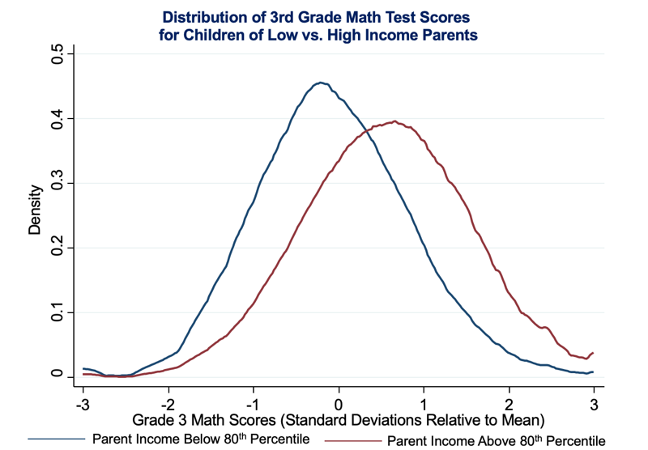

* Exactly how much of the gap in innovation is explained by these differences third grade test scores? We estimate this using a technique called **propensity score reweighting,** which allows us to figure out what the patent rates for low-income kids would be if they had the same distribution of grades as high-income kids.
* For instance, suppose that there are twice as many high-income kids who get an A than those who get a B, whereas with the low-income kids it's a one to one ratio. In order to make the low-income kids resemble the high-income kids in terms of their distribution of grades, we're going to count the kids who got an A in the low-income group twice as much as the kids who got a B.
* We find that if low-income kids had the same test score distribution in 3rd grade as high-income kids, the gap in innovation rates by parental income would fall by 31%.
* If we use data on test scores in later grades, we find that the later you measure test scores, the more of the gap in innovation in adulthood you are able to explain.

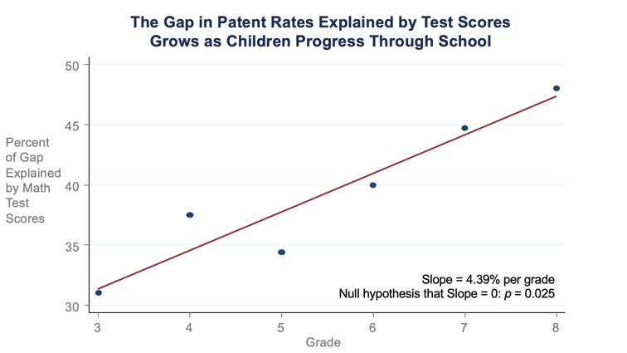

1. ***Disparities in Patent Rates by Race and Gender***

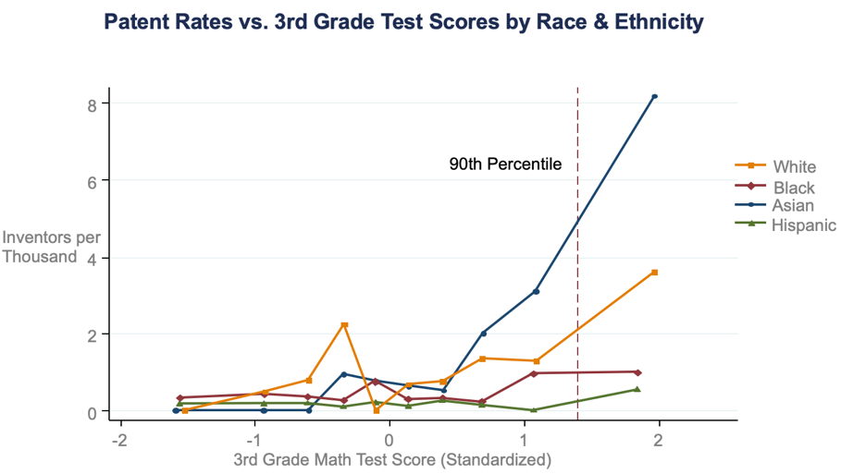

* Cutting the data by race and ethnicity instead of parent income illuminates a similar pattern. White kids and Asian kids scoring at the top of their third-grade math class are much more likely to become inventors. However, for black and Hispanic kids, the relationship is flat. Even if a black kid is at the top of their third-grade math class, their probability of becoming an inventor is still near zero.

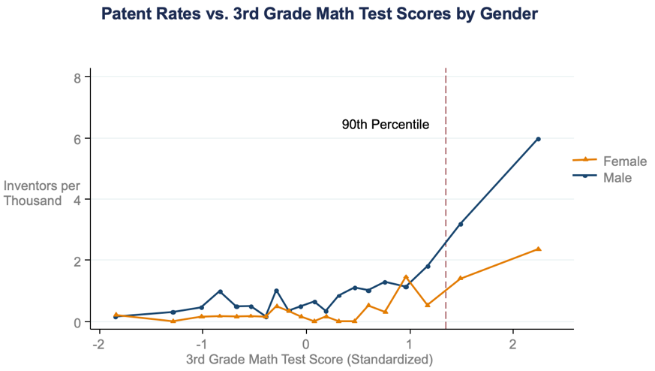

* Boys at the top of third grade math class are much more likely to become inventors than girls at the top of their third-grade math class.
* On the gender dimension, we can also get a sense of how this pattern is changing over time by looking at what fraction of inventors are women by the year in which they are born.
* Among people born in 1940, 8% of those who had patents were women. This is increasing steadily, those very slowly over time. It’s going to take another 118 years to reach gender parity in innovation in the U.S.

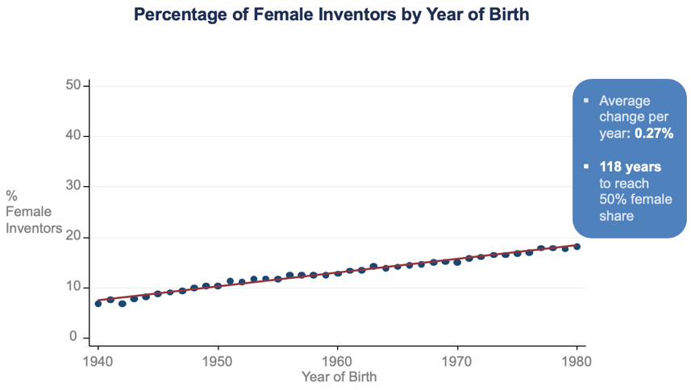

* These results suggest that most of the innovation gap across income, race, and gender is not due to ability differences. However, tests are an imperfect measure of ability, and we have no causal evidence of changes having a causal effect in the patterns thus far.

1. ***Effects of Childhood Environment on the Innovation Gap: Impact of Parents on Patent Rates***

* We also directly study the effects of environment by focusing on the effect of exposure to innovation during childhood through family and neighbors.
* We first analyze the relationship between kids' patent rates and their own parents' patent rates.

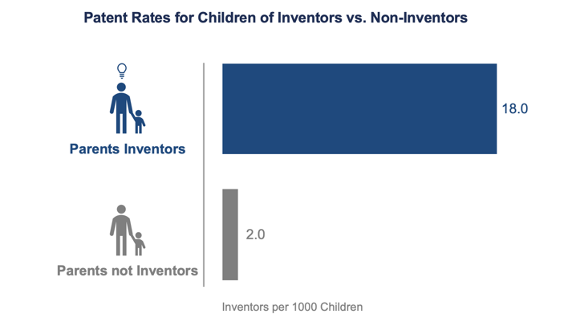

* Kids are about ten times as likely to go on to have a patent themselves if their parents had a patent. This could reflect genetics, but it could also be about exposure.
* Patent rates allow us to isolate the causal effect of exposure by analyzing the propensity to patent by specific technology class. Patents are classified into very narrow technology classes. The basic assumption we make in order to isolate the causal effects of the environment is the idea that genetic ability to innovate is very unlikely to vary across very similar technology classes.
* We first quantify the distance between two technology classes by looking at how many people there are who have patents in two given classes.
* We assume that someone can't have a gene to specifically be good at inventing in one technology class but not the other if the two are very similar. We then ask if kids are more likely to invent in the exact technology class in which their parents did. We find that this is indeed the case. The impact of having a parent who has a patent does not cross over much to different technology classes.

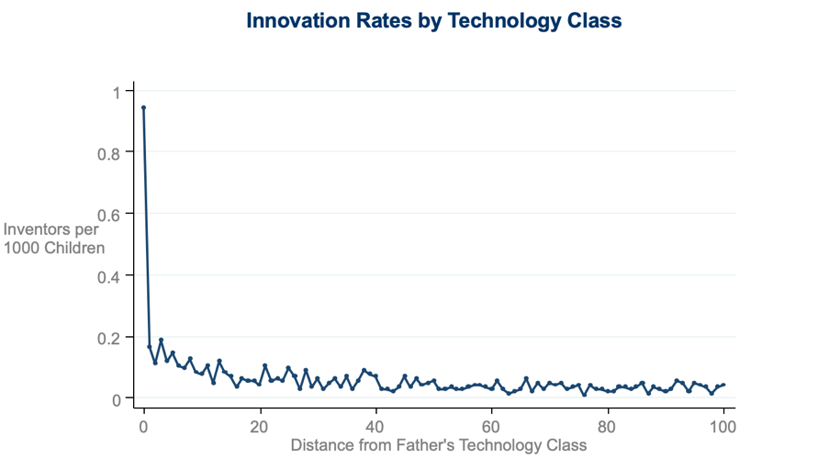

* That is compelling evidence that the mechanism is not actually about genetic transmission ability, but rather exposure.

1. ***Effects of Childhood Environment on Patent Rates: Impact of Neighbors***

* We also analyze a broader source of influence, neighbors. This map shows you the geographic origins of inventors.

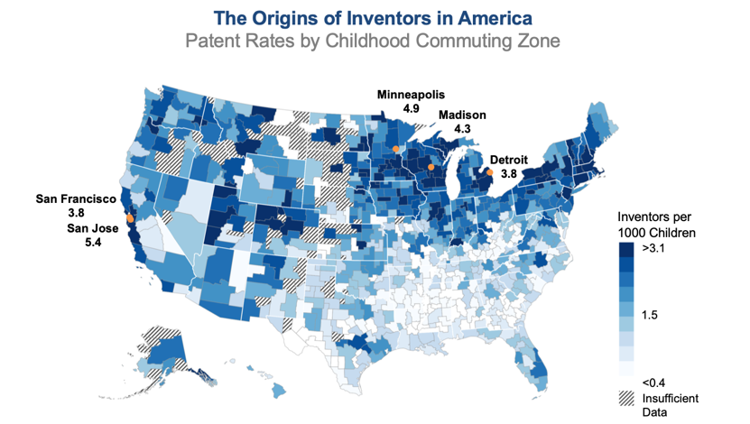

* The Northeast and the West Coast generally have higher rates of innovation, while the Southeast has lower rates of innovation. There's some correlation with the upward mobility outcomes, but there are some pretty stark differences, too.
* Kids who grow up in commuting zones with a lot of adults in the innovation field are more likely to become inventors in adulthood. It’s the same kind of mechanism that we see with parents.



* We estimate a fixed effects regression model using technology classes to see whether these geographic differences are driven by the causal effects of place rather than just sorting. We find that children are more likely to patent in the specific technology class in which adults in their area are inventing.
* This suggests that exposure and environment have an important causal effect.
* Differences across geographic areas in the production of inventors are unlikely to be due to broad factors like geographic differences in the quality of schools or differences in the resources across regions and neighborhoods. A more plausible explanation is that exposure effects are direct exposure effects driven by things like mentoring or role models.

1. ***Gender-Specific Innovation Exposure Effects***

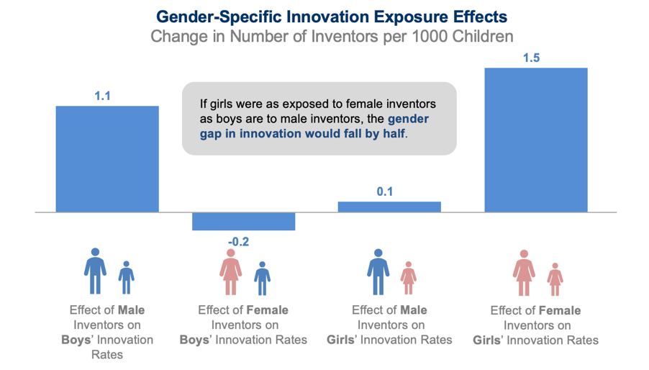

* Looking at the data by gender, we see a similar pattern.
* As a boy, if you grew up in an area where there are relatively many male inventors versus an area where there are few male inventors, the odds that you become an inventor increase by about one in 1,000.
* Boys’ probabilities of becoming inventors are greatly influenced by what the men in the area are doing, but not by what the women are doing.
* If girls grew up in an area with many male inventors as opposed to relatively few male inventors, there's no impact at all on their probabilities of becoming inventors. However, if they grew up in an area with many female inventors, they're much more likely to become inventors than if they grew up in an area with very few female inventors.
* Thus, these exposure impacts, which point to channels like mentoring or role model effects, are gender-specific.
* If girls were as exposed to female inventors as boys currently are to male inventors, the gender gap in innovation would fall by half.

1. ***Development of Gender Stereotypes during Childhood***

* Bian et al. (Science 2017) present further evidence supporting this view that the gender gap in innovation is driven by aspirations and preferences by conducting experiments to analyze the development of gender stereotypes about intellectual ability.
* They find evidence that gender stereotypes develop over time in children, which could lead to the types of career patterns we’ve seen in the data. They also find that by age 6, girls are more likely to step away from games that are labeled “for really, really smart children”.

1. ***The Dynamics of Gender Gaps in Innovation***

* This evidence suggests that the gender gap in innovation is, in some ways, self-perpetuating due to social norms and aspirations. The under-representation of female scientists in the current generation effectively reduces the number of female scientists and inventors in the next generation because these exposure effects are so important.
* That could be part of the reason why the gender gap in innovation is closing at an incredibly slow rate of roughly .25% per year, meaning it will take 120 years to close the gap completely.

1. ***Lost Einsteins: The Importance of Exposure to Innovation***

* We try to quantify the impacts of the various disparities in innovation through a phenomenon that we label “Lost Einsteins”, the idea that there are lots of people who could have gone on to have impactful innovations but lacked exposure to innovation and resources in childhood.
* If women, minorities, and kids from low-income families were to invent at the same rate as high-income white men, the innovation rate in America would quadruple.
* If we think of innovation as the central driver of economic growth, this is potentially a big cost to the aggregate economy.
* In response to this paper, there’s more been attention to this issue. For instance, the group Pioneer is trying to identify more of these Lost Einsteins and break the mold of the typical people who are receiving venture capital funding and starting companies in Silicon Valley.
* More broadly, you might worry that efforts like this to increase equality of opportunity might actually adversely impact economic growth. I think this is a good example of where you can help people achieve better outcomes themselves and, in the process, help society by strengthening the innovation pipeline.